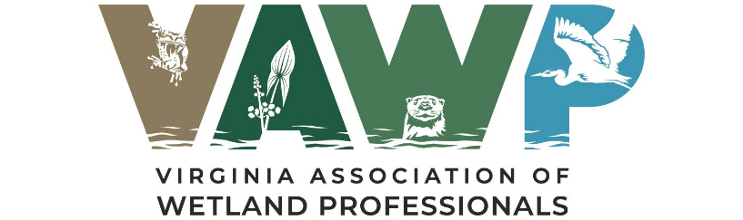
Call for Student Posters
VAWP SPRING MEETING

VIRGINIA CROSSINGS HOTEL & CONFERENCE CENTER, MAY 8, 2026

GLEN ALLEN, VIRGINIA

The Virginia Association of Wetland Professionals (VAWP) is a state-wide organization that was established to unite wetland scientists, regulators, managers, design professionals, academics, attorneys and other wetland and environmental science professionals in an independent forum that promotes the discussion and exchange of ideas on wetlands and other environmental science issues important in Virginia.

The VAWP is seeking undergraduate and graduate students to participate in our Student Poster Session at our Annual Spring Meeting. Posters related to research focused on wetland science, natural resource, or other related environmental science fields are all welcomed. This meeting will be held on Friday May 8, 2026, at the Virginia Crossings Hotel & Conference Center in Glen Allen, Virginia.

Our meetings are typically attended by representatives from various consulting firms, academic institutions, local governments, and state and federal regulatory agencies. A poster session will be held during one of the meeting breaks to provide an opportunity for informal, interactive presentations and discussions between researchers and the general VAWP membership. This is a forum for exchanging ideas, discussion on your work, and to engage with representatives in the industry. Poster session participants are also invited and encouraged to attend the other VAWP meeting presentations.

Student Poster Recognition Award
VAWP will recognize the most outstanding student poster presentation, as determined by a popular vote of meeting attendees. The winner will receive formal recognition during the meeting and a token of appreciation for their excellent work.

Submission requirements:
If interested in our poster session, please submit a completed Student Poster Registration Form to Robert Sullivan, VAWP Education Committee Chair (rsullivan@tntenv.com) by April 24, 2026. The VAWP Board will review each submission for acceptance and notify you. Preference will be given to poster topics that align with the VAWP mission.

Registration: Registration fees will be waived for all students presenting in the poster session. Each student is responsible for providing their own easel for the presentation.

Follow us on Facebook! Check out our Website!
https://www.facebook.com/vawetlands.org http://vawetlands.org/

2026 VAWP SPRING MEETING

VIRGINIA CROSSINGS HOTEL & CONFERENCE CENTER, MAY 8, 2026

STUDENT POSTER REGISTRATION FORM
The Virginia Association of Wetland Professionals (VAWP) is seeking college and graduate students to participate in our Student Poster Session at our Annual Spring Meeting. This meeting will be held on May 8, 2026, at the Virginia Crossings Hotel & Conference Center in Glen Allen, Virginia.

Registration fees will be waived for all students presenting in the poster session. Each student is responsible for providing their own easel for the presentation.

If interested in our poster session, please submit a completed form to VAWP Education Committee Chair (rsullivan@tntenv.com) by April 24, 2026. The VAWP Board will review each submission for acceptance and notify you.

STUDENT NAME SUBMITTING POSTER:

ACADEMIC INSTITUTION:

EMAIL ADDRESS:

CELL NUMBER:

POSTER TITLE:

RESEARCH AUTHORS & ACADEMIC AFFILIATIONS:

ABSTRACT (250 word maximum):

