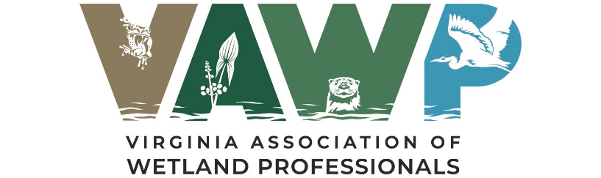
CALL FOR APPLICATIONS
SPRING 2026
Student Research Scholarship
Call for Applications
Spring 2021

Follow us on Facebook! Check out our Website!
https://www.facebook.com/vawetlands.org http://vawetlands.org/

The Virginia Association of Wetland Professionals (VAWP) is soliciting scholarship applications from undergraduate and graduate students enrolled in Virginia institutions. This year, VAWP is offering a $1,000.00 scholarship to outstanding student pursuing research focused on wetland science, natural resource, or related environmental science fields. The student’s research must demonstrate a specific interest in advancing the mission and ideals of the VAWP. Scholarships will be paid directly to the selected applicant.
Applicant Minimum Criteria include:
- A minimum GPA of 3.0.
- Current enrollment in a Virginia undergraduate or graduate degree program in a wetland science / natural resources / environmental science or related field.
- Currently conducting or planning research in the environmental science field.
- Plans to pursue a career in the environmental sciences.
- A commitment to present the research at a future VAWP event.
Applicant Process
Complete the Scholarship Application Form and provide all requested information. Application materials must be submitted electronically to Robert Sullivan, VAWP Education Committee Chair (rsullivan@tntenv.com) by Friday April 24, 2026. If you have any questions, please contact Robert Sullivan.

Selection Process
Applications will be evaluated for completeness and qualifications for meeting the applicant requirements. All qualifying applications will then be independently reviewed by the VAWP Education Subcommittee. Note that Board members or Education Committee members who are involved in a student’s research will be recused from the selection process.
Evaluations will be based on the following criteria:
- Clear statement of hypotheses, objectives, or research questions (20%).
- Significance or potential impact of the proposed research to advancing knowledge and understanding in its field (20%).
- Creativity or originality of the approach or concepts in the proposed research (20%).
- Relevance of the proposed research as related to the aims of the VAWP (20%).
- Letters of recommendations (12%).
- Quality of Personal Statement (8%).

Award selection will be announced during the VAWP Spring Meeting on Friday May 8, 2026. Applicants are not required to attend the meeting to qualify but are encouraged to attend if able. See VAWP website for registration details. All applicants will be notified of status following the VAWP Spring Meeting.

Complete Scholarship Application Form and provide information requested below. Application materials must be submitted electronically to Robert Sullivan, VAWP Education Committee Chair (rsullivan@tntenv.com ). Information can be provided as attachments (PDFs preferred) or in the body of an email. If you have any questions, please contact Robert Sullivan.

- Research Summary
The research summary must include a title limited to 180 characters and a narrative of the research limited to 1,200 words.

The research narrative must include the following:
- Background about the research topic to convey its relevance and significance as specifically related to the VAWP, wetland science, natural resource, and/or environmental science fields.
- A clear statement of hypothesis, objectives, or research questions.
- A description of methodological approach to be used, including a description of study sites, spatial and temporal intensity of sampling, tools and/or procedures used to generate data and planned quantitative or statistical treatment of data.
- A description of how collected data will permit interpretations and/or conclusions relevant to the proposed research.
- Personal Statement
A statement about your career goals after graduation and why you should receive the scholarship award. Please include any school, professional or community activities you have participated in, any offices held, and any awards received. Statement should not exceed 300 words.
- Recommendations
Provide as PDFs. Two letters of recommendation are required. One letter must be written by the applicant's research advisor. The second letter should be written by an individual familiar with the applicant and their research and/or career goals in environmental science. Each referee must clearly identify the nature of their relationship with the applicant. The research advisor letter of reference must clearly and directly address the proposed research and the applicant's role in project development and initiation, taking into consideration the academic stage in the applicant's career (e.g., seeking a bachelor's, master's, or doctoral degree). Letters also should evaluate the likelihood that the work will be successfully completed.
- Proof of Enrollment at a Virginia Institution
Provide a copy of your tuition receipt or current registration card.

- Academic Transcript
Include a copy of transcript. Unofficial is acceptable.
Spring 2026

